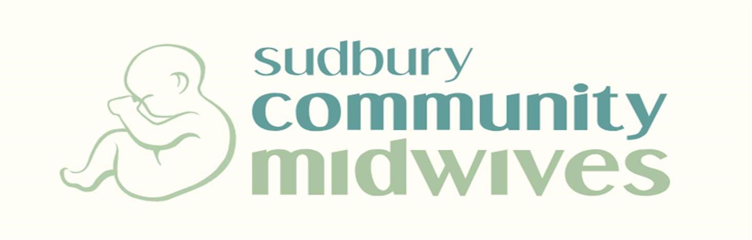
1571 Paris Street Sudbury, Ontario P3E 3B7
Sudbury Community Midwives, established in 1993, is seeking an associate midwife for limited term contract (leave coverage). New Registrants and General Registrants will be considered.

About us:

Located in the largest city in Northern Ontario, our practice services the Greater City of
Sudbury and surrounding areas. Midwives are privileged at a single hospital, Health Sciences North. The community annual birth rate is approximately 1800 births; our well-established practice of 12 midwives enjoys a 40% planned out-of-hospital birth rate. Midwives practice Full-Scope (Epidurals and Oxytocin) and enjoy good collegial relationships with OB colleagues. Our practice is committed to a healthy work-life balance and supporting newer graduates; our team approach to service delivery is effective in meeting the needs of both clients and midwives.

Sudbury offers an affordable lifestyle with lower housing costs compared to other urban centres. Surrounded by lakes and wilderness, Sudbury is home to world-renowned attractions, urban comforts, and four-season outdoor adventures. A multilingual community, the practice services a diverse spectrum of clients.

Our ideal candidate will join the practice between April 1st and August 1/2024 (we are flexible!) and will remain with us until June 2025. Caseload will be built for your arrival.

Come join a fantastic group of midwives! Please email your CV and cover letter (or questions about this position), to scmppracticemeeting@gmail.com as soon as possible. We thank all those who apply; only those selected for interview will be contacted. Interviews may be held in-person or virtually. We look forward to working with you!

Visit our website at: www.Sudburymidwives.com to see images of our beautiful clinic birthing space!

