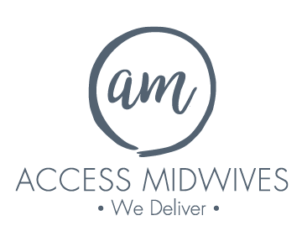

We have approved funding for one

New Registrant

Start date October 1, 2025.

We are a teaching practice with privileges at McMaster
University Medical Centre where we enjoy excellent relationships with healthcare
teams and consultants. Located in East Hamilton, we serve a socially and
ethnically diverse community within the greater Hamilton/Stoney Creek area. Our developing
partnerships with local social agencies have enabled us to care for women with
exceptional social needs.

Please send your letter of interest and resume to:
Email: admin@accessmidwives.com

Attention: Tamara Youngberg

We thank all who are interested, but only those granted an interview will be contacted.

