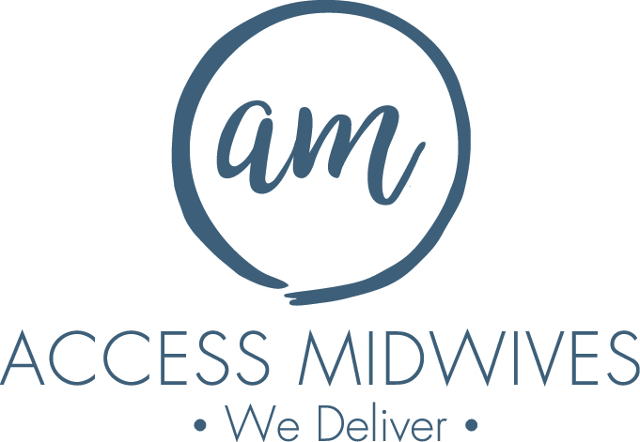

We have one opening for a
General Registrant

Start date April 6, 2026

We are a teaching practice with privileges at McMaster University Medical Centre where we enjoy excellent relationships with health teams and consultants. Located in Hamilton, we serve a socially and ethnically diverse community within the greater Hamilton area. Our developing partnerships with local social agencies have enabled us to care for women with exceptional social needs.
FULL SCOPE EXPERIENCE REQUIRED
This General Registrant position would be working in our triple team model. One of the greatest benefits of working in our triple team is the ability to enjoy generous off-call time for a better work/life balance.

Please send your letter of interest and resume to:
Email: admin@accessmidwives.com
Attention: Tamara Youngberg

We thank all who are interested, but only those granted an interview will be contacted.

