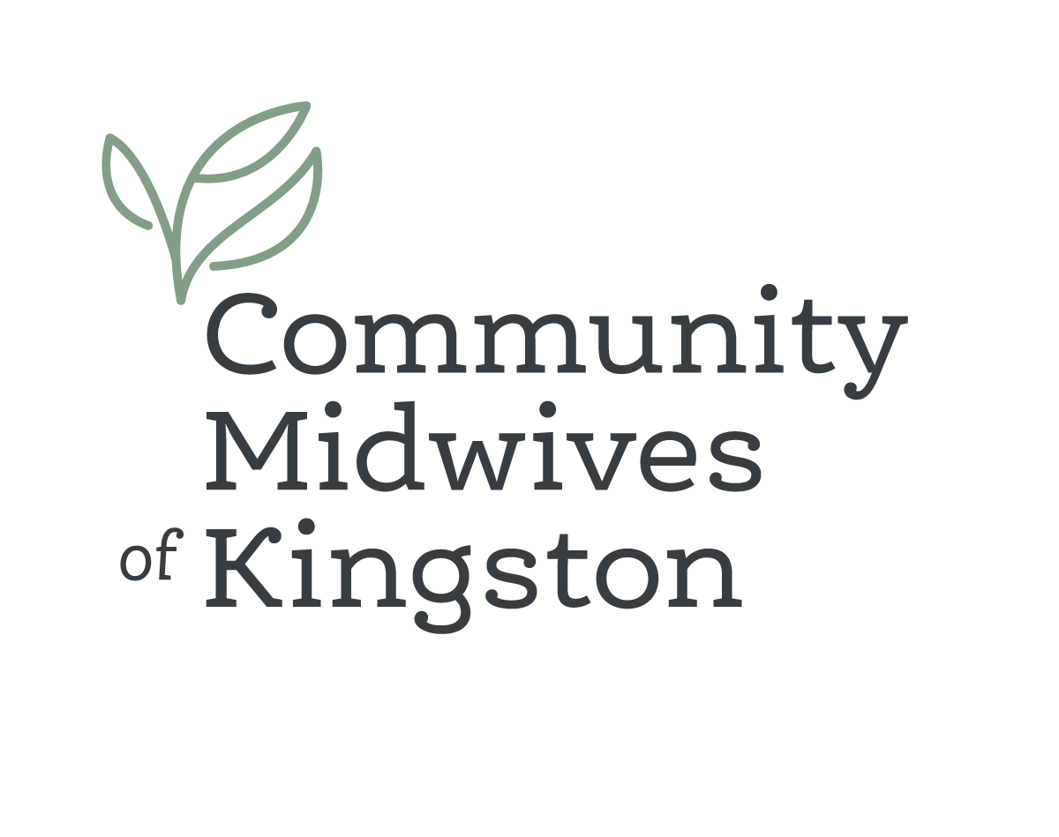
Locum Position
Seeking 2026 locum; Flexible start & end date; Let us know what you are looking for!
We are a growing team of 17 midwives known for our strong sense of humour and commitment to maintaining a healthy work-life balance. Our practice is grounded in collaboration, mutual support, and thrives on shared responsibility and creative call models.
Our well-established practice is supported by an exceptional administrative team and utilize Accuro EMR. Our newly built clinic space includes a birth room with a birthing tub and thoughtfully chosen amenities designed to support a calm, comfortable, birthing option for Kingston families. We are strong supporters of home birth as a valid and informed choice for families.
We are seeking a General Registrant to join our team, with a flexible start date. The successful candidate will be supported through a one-month clinic and orientation period, followed by an ongoing caseload of approximately 32–40 BCCs, adjusted based on individual preferences and sustainability. Team structure and on-call scheduling will be developed collaboratively once a start date is confirmed. While two midwives are currently on parental leave, this is anticipated to be an ongoing position due to strong TPA support and a substantial waitlist from April onward.
We hold privileges at Kingston Health Sciences Centre (KHSC) and maintain excellent, collaborative working relationships with obstetricians, nurses, anaesthesia, and hospital leadership. Our scope includes epidural and induction management, water birth using stand-alone tubs, and oxytocin inductions through a collaborative model that returns care to midwives once active labour is established. KHSC is a Level 3 teaching hospital affiliated with Queen’s University, offering opportunities to engage in interprofessional education with RN, NP, medical students, and GP fellows, should this be of interest.
Kingston is a vibrant, welcoming city that offers a rich mix of arts, culture, dining, and outdoor recreation. With a lively downtown, easy access to rural landscapes, and proximity to Toronto, Ottawa, and Montréal, Kingston offers flexibility for many lifestyles and family configurations, all along the stunning shores of Lake Ontario.
Our Commitment to Equity and Inclusion
We are committed to fostering an inclusive, respectful, and supportive workplace. We encourage applications from midwives who identify as Indigenous, Black, racialized, 2SLGBTQIA+, disabled, or from other equity-seeking communities, as well as those returning to practice or seeking a supportive transition into a new team. Let us know if you require accommodations throughout the recruitment and onboarding process.
If you are interested in joining a collaborative practice that values sustainability, humour, and respectful care—for both clients and colleagues—we would love to hear from you. Please send a CV and letters of reference to:
info@kingstonmidwives.ca attn: Kaz McKinley-Jones RM.

