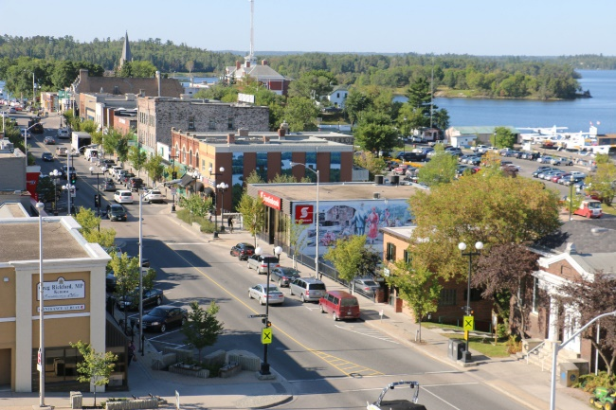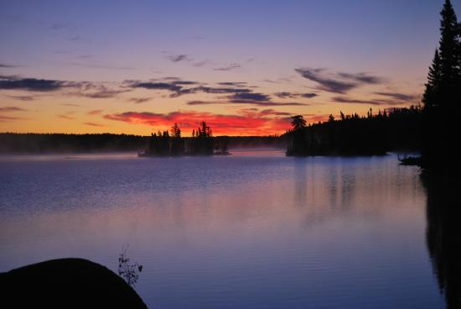
General Registrant LOCUM: July-August 2026
We are looking for General Registrant locum coverage for all of July and August, 2026.
We are a very busy rural/remote, two-midwife, primary care practice in a small, beautiful community in Northwestern Ontario, serving Kenora and surrounding reserves/communities. We are the only two delivering midwives between Thunder Bay and Winnipeg, and we work to the fullest possible midwifery scope including inductions, epidurals, medical abortions and contraceptive care. We are seeking a locum(s) to cover extended vacation time for midwives in the practice.
EVERYTHING including holidays, off-call time and length of stay is negotiable. The locum will be funded exclusively by the AOM block incentive fee, and will cover clinic and postpartum visits, and attendance in the role of second attendant for OOH deliveries, but will NOT include attendance at deliveries in the role of primary.
We currently have privileges at Lake of the Woods District Hospital (Level 1) and have strong working relationships with the hospital administration, physicians and nurses. There are no Obstetricians in Kenora so we work closely with 5 family physicians, with whom we have excellent relationships. We refer our high-risk clients to Obstetricians in Winnipeg, Manitoba when necessary.
Midwives in the community are actively involved in hospital committee work, including Medical Advisory Council, Midwifery Service and Perinatal Committees, MoreOB, and we teach NRP, Fetal Health Surveillance, and Emergency Skills.
For the outdoor enthusiast, our community lies within the heart of Central Canada’s Lake of the Woods region. This area offers fishing, hunting, hiking, cycling, boating, beautiful beaches, and small-town hospitality. Our population is about 15,000 in the off-season with those numbers tripling in the summer months. We are located 222 km north of the Canada/USA border, 200 km east of Winnipeg and 560 km west of Thunder Bay on beautiful Lake of the Woods.
For more information on Kenora
- https://www.kenora.ca/en/visit-play/tourism-information-centres.aspx
- https://visitsunsetcountry.com/tourism-kenora
Interested midwives please call Bekkie or Kelly at 807-468-8510 or email us at kenoramidwives@shaw.ca.

