

Seeking Locum Coverage for Midwives of Lindsay for January 5-16, 2026
We are seeking a midwifery locum for our Lindsay office. Come join us for clinic and home visits; and potentially home birth back-ups in our beautiful region!
Our vision is to be the regional centre of excellence offering compassionate, holistic, and comprehensive midwifery services for pregnant and parenting people in the City of Kawartha Lakes. We are all committed to our values:
AUTHENTICITY:
We will treat each other and clients as unique autonomous individuals and be open, honest, and trusting.
COMMUNITY:
We will work with community partners to expand services, support clients with wrap around care, and create a welcoming environment.
KINDNESS:
We will treat each person with respect and compassion, and recognize the good in each person.
ACCOUNTABILITY:
We provide primary health care that is safe and evidence based. We will support client accountability for their health and choices. We will be transparent to clients, our team, funders and the general public.
GROWTH:
We are continually open to new ideas and leaders in change. We are committed to lifelong learning.
RESPECT:
We will honour every person and advocate for client choices based on informed choice principles.
TEAM:
We value the unique strengths and gifts that each person brings to our community. We support one another, invest in relationships, and meet each other from a strengths-based approach.

Our clients come from a wonderful variety of backgrounds including lovely farm families, Amish and Mennonite families, low-income families, newcomers to Canada, Indigenous clients, and LGBTQ couples. We have a 35% home birth rate.
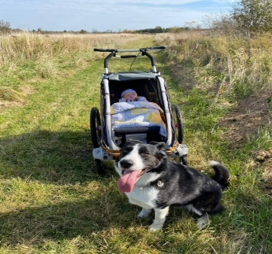



If our vision and values resonate with you.
If you enjoy rural communities with the benefits of urban centres not too far away – we would love to hear from you!
For more information about us, please go to www.midwivesoflindsay.ca
Please send your resume to midwivesoflindsay@gmail.com

