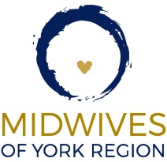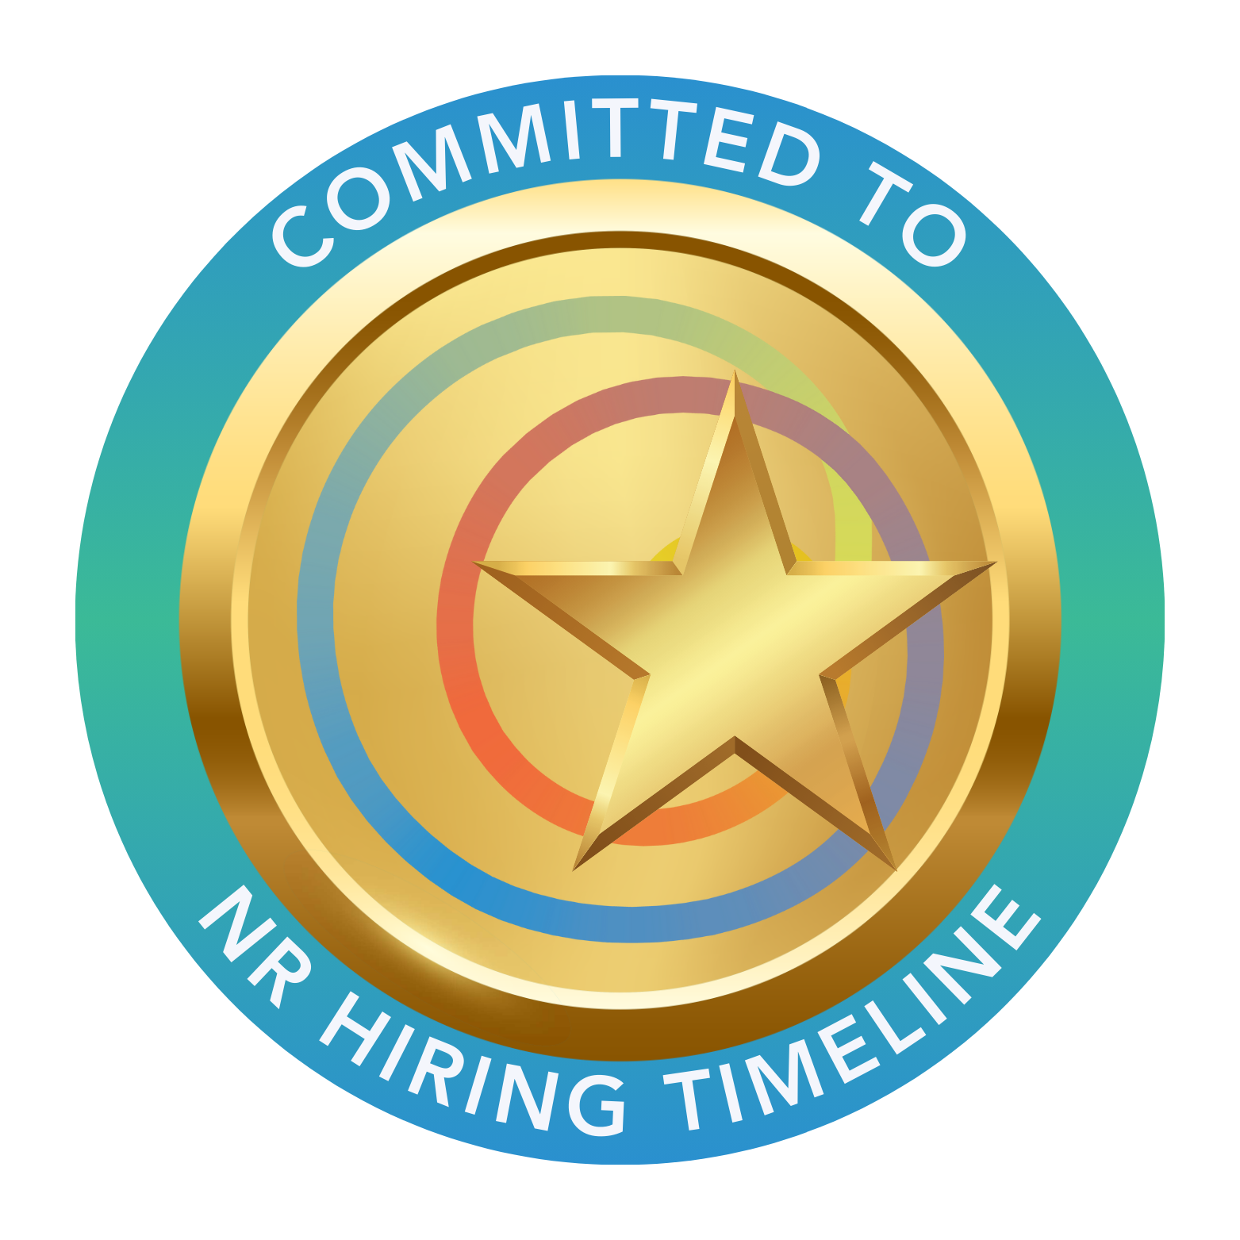
MIDWIVES OF YORK REGION SEEKING 1 NEW REGISTRANT
Position available for a new registrant starting in 2026. The new midwife will be joining a team or could work primary call. It is a minimum one-year contract position, with potential for extension.
We are a group of 11 midwives with MEP and IMPP routes of entry and work with flexible caseloads. All NR’s start 1-month primary call for orientation to the clinic and the hospital. The NR will be assigned a mentor(s) from the practice group. The mentor(s) provide ongoing support, regular reviews, and be available to answer questions or concerns. We are supportive of one another and try to work collaboratively. We are committed to promoting a positive work life balance for all our midwives.
Our catchment area is York Region, extending from Lake Simcoe in the north to Elgin Mills Road in the south, Highway 27 in the west to Highway 48 in the east. This area is comprised of urban, suburban, and rural communities with a growing multi-cultural population. We have a spacious midwifery clinic in Aurora. We use ACCURO EMR. We also have wonderful, helpful office staff. Most months we have a wait list of families seeking midwifery care.
Our hospital privileges are at Southlake Health in Newmarket. We are a well-established practice with good hospital relationships. We work in full scope with epidural and oxytocin augmentation /induction privileges. An interest in working collaboratively and desire to contribute positively to interprofessional relationships is essential.
We are seeking an energetic midwife keen to share clinical and administrative duties. Our midwives are active participants on various hospital committees, community health organizations and participate in ongoing community outreach. A sense of humour is welcome!
BIPOC and LGBTQ new registrants are encouraged to apply. Please send a letter of introduction and resume to Kristine Reynolds at yrmidwives@gmail.com.
We thank you for your interest, but only those candidates selected for an interview will be contacted. We are planning on doing interviews in March; however, we will be accepting resumes on going.

